Name _______________________________________________________ Date ______________ Period_________
Answer the questions based on Physical Science the questions.
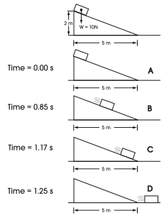

Inclined Plane Experiment
- What is the weight of the block on the inclined plane?

- At what time is the box released down the inclined plane?

- Over the course of the experiment, how far down does the box drop?

- Over the course of the experiment, how far does the box travel from left to right?

- At what time does the box have the greatest kinetic energy?

- Where is the potential energy of the box the greatest?

- Choose the correct answer: The weight of the box is a measure of the ________________.
  - Velocity of the box while sliding
  - Friction between air and the box
  - Kinetic energy at the top of the incline
  - Force acting on the box due to gravity

Example | Acceleration (m/s²) | Force (Newtons) | Mass (kg)
1 | 1 | 1 | 1
2 | 2 | 20 | 10
3 | 1 | 10 | 10
4 | 1 | 20 | 20
5 | 0.5 | 10 | 20
6 | 2 | A | 50
7 | 10 | B | 45
8 | 75 | 600 | C

This table demonstrates how Force = Mass x Acceleration.
- Which two examples from the table show when mass doubles and acceleration stays the same, force doubles?

- What is the force for example #6 (Box A)?

- Using the table above, explain what would happen to the force of something if you doubled its acceleration while reducing its mass by half.

- Write correct number for the missing blanks (B and C), don’t forget the units.
B __________________
C __________________

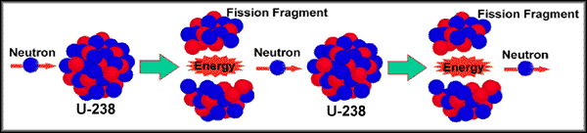

- Does this represent the splitting or does it represent the combining of atoms?

- When a neutron hits an atom of Uranium-238, what is produced?

- This reaction is called a chain reaction. Looking at the example give 2 reasons why it is called that. Answer as a 2-point short answer question

- Using the diagram above and your own knowledge of fusion, explain one difference and one similarity between fission and fusion. Answer as a 2-point short answer question.

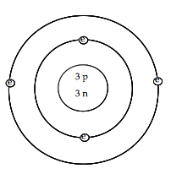

- List the three subatomic particles shown here along with their charges.
_________________________
_________________________
_________________________

- For the atom above, what is the mass of this atom?

- How many total electrons are there? Is this atom positive, negative or neutral? How do you know?

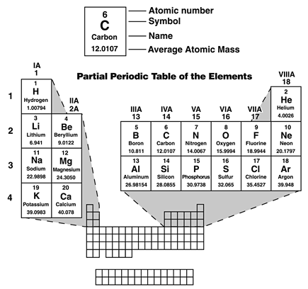

- How many protons does Lithium have?

- How many neutrons does Calcium have?

- Predict how many electrons Potassium, Sulfur and Argon should have if the atoms are neutral in charge.
Substance C
Substance Y
Substance A

Substance X
Substance B

pH 12
pH 3.7
pH 7.3
pH 9.4
pH 11

Acids and Bases
  - Of the substances with the pH displayed, which one is the most Basic and which one is the most Acidic?

  - Looking at the pH’s here, which one is most likely water?

  - The substance in the container marked X begins to fizz and bubble when poured onto a pile of baking soda. What could you say about this substance based on that observation?

Net Force
For each of diagram, determine the net force acting on the object. When forces are moving in the same direction they are added and the net force is the sum of the forces. When forces are moving in opposite directions you subtract the smaller force form the higher force. The net force is what is left over from the higher force.
Example:
2 N
4 N

Net force: 4 N – 2 N = 2 N to the left. Change in motion: The box will move to the left.
2 N
4 N

Net force: Change in motion:

5 N
8 N
10 N
Net force: Change in motion:

2 N
10 N
10 N

Net force: Change in motion:

Potential and Kinetic energy
Formulas:
KE = ½ mv² (m = mass, v = velocity)
PE = mgh (m = mass, g = gravitational constant (9.8 m/s²), h = height in meters

Circle the one with more Potential energy and briefly explain why.
- A 25 kg mass or a 30 kg mass at the top of a hill?
- A car at the top of the hill or the bottom of a hill?
- A plane on the ground or a plane in the air?
- A full plane or an empty plane (both are flying)?

Circle the one with more Kinetic energy and briefly explain why.
- A 25 kg mass or a 30 kg mass going 5 m/s.
- Two 10 kg masses, one going 75 m/s, one going 45 m/s.
- A car at rest or a car rolling down a hill.
- A heavy bike or a light bike.

For the following questions……..PE or KE?

- _____ A car is traveling 45 mph.
- _____ A rock is on a ledge 5 meters high.
- _____ A car is resting at the top of a hill.
- _____ A ball is thrown into the air and is still moving.
- _____ _ A ball rolling on the ground.

Calculations (Use your formulas and show ALL of your work)
- A 4 kg rock is rolling 10 m/s. Find its kinetic energy.

- A 8 kg cat is running 4 m/s. How much kinetic energy does it have?

- A 4 kg bird is flying with a velocity of 4 m/s . What is its kinetic energy?

- Find the work done by a 25 N force applied for 6 meters.

- Calculate the potential energy of a 5 kg object sitting on a 3 m ledge.

