**Name _______________________________________________________ Date ______________ Period_________**

Use the graphs, charts, and tables to answer the questions.

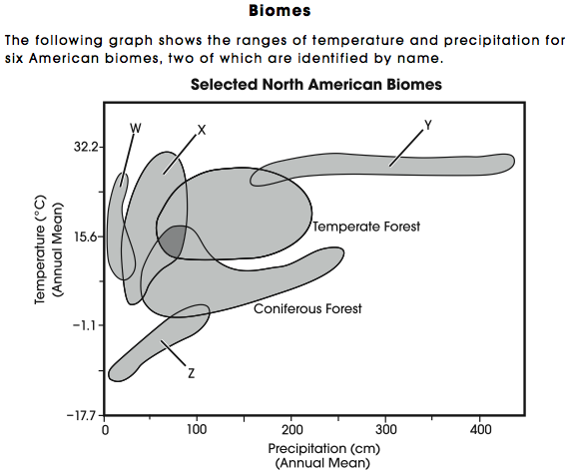

1. What is shown in this graph?
2. What is the value on the y-axis and x-axis?
3. What third piece of information is shown inside the diagram?
4. Which biome (or letter) shows the lowest annual temperature?
5. Which biome (or letter) shows the highest annual precipitation?
6. Identify the **temperature** range (minimum to maximum) of the temperate forest and the range (minimum to maximum) of **precipitation** for the coniferous forest?
7. Deserts are consistently the driest biomes in North America. They consistently receive very little precipitation but have a wide variation in mean annual temperature. Which letter for a biome likely represents the deserts?

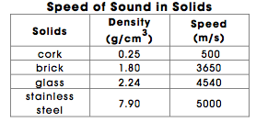

1. What are the three pieces of information available in this table?
2. What is density defined as and what is speed defined as in the table?
3. What is the density of glass? Include units. What is the speed of sound in brick? Include units.
4. Which two substances have the lowest and highest densities?
5. Which two substances have the slowest and fastest speed of sound?
6. What is the **relationship** *(how do they affect each other*) between density and the speed of sound?
7. Air has a density of about 0.001 g/cm3. Based on the information seen here, make a **prediction** about the speed of sound in air.



1. What information does this chart show?
2. Which layer was formed most recently (youngest)?
3. Which layer was formed the longest time ago (oldest)?
4. What geologic law describes the **correlation** with layer order and age?
5. Did **glaciers** move through this area? How do you know?

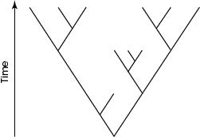

The above diagram is a **cladogram**, diagram that shows the relationship between species of organisms. Each letter represents a different species.

1. Which two **species** (represented by letters) are the most closely related?
2. Where would you find the **organisms** that went extinct the longest time ago?
3. Which species gave rise to all the species on the diagram?
4. Is species A was a land dwelling animal and species F was **aquatic** what could you say about the evolution of species A?
5. 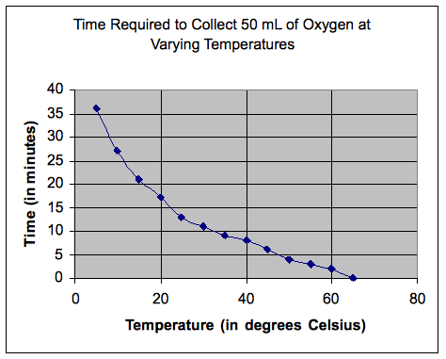What prediction could you make regarding the **DNA** of each species on this particular cladogram?
6. About how long does it take to collect 50 mL of oxygen at 40 degrees Celsius?

1. At what temperature does it take 20 minutes to collect 50 mL of Oxygen?
2. Which time interval demonstrates the smallest **range** in minutes for oxygen collection?
3. What can you say about the collection of oxygen as temperature increases?